Marco van der Merwe - 35314389

A space adventurer company in the year 2077 wants a system that will help them sort their spaceships according to the spaceships acceleration.

My “sortSpaceships” method makes use of 3 pointers and one new linked list. It uses one pointer named “ptr” that is assigned to the head of the calling list and uses this pointer to append all the values of the calling list to the new linked list called “sortedlist” that it then sorts. It sorts this list using the other two pointers named “firstptr”, and “secondptr”. It traverses through the list with a while loop nested within a for loop that uses “ptr” to iterate through the number of nodes in the linked list. Within the while loop we check if the first pointers element is larger than the second pointers element, and if so, we swap them using a hold node that we assign to the second ptrs element. We continue to do this until the largest value is at the end of the list, and the while loop is broken by checking if the second pointer is equal to null since we assign each pointer to its next value after checking which value is larger. After the for loop has iterated through the entire linked list, we return the sorted list.

Each of my spaceship classes (explorer spaceship and fighter spaceship) which extends my spaceship class has an overwritten compareTo() method which my spaceshipSorter method used to check if the firstptr element is larger than the secondptr element:

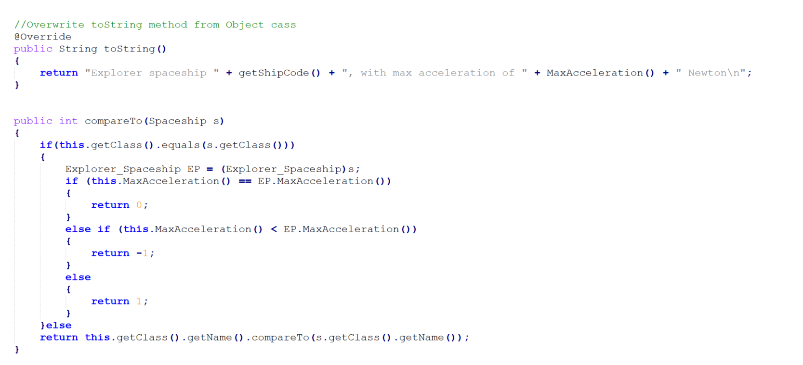

Note:

I would gladly submit my spaceship classes from I_DO 1 since they are required to get the desired output of my test program, but it is specifically requested that we only submit the three files that I have submitted. Thus, I will add screenshots of my test program output in this word document.

